**EEB1453 Week 6: Exploring Dynamics of SIR Models**

**Part I) Waning Immunity:**

W=0.1

R0=0.5

R0=1.0

R0=1.5

R0=3.0

W=0.01

R0=0.8

R0=1.0

R0=1.1

R0=3.0

**Part II) BD separated**

Birth rate =0.03 Death rate=0.02 (Growing Population Scenario)

R0=0.8

R0=1.0

R0=1.5

R0=3.0

Death rate = 0.1 Birth rate = 0.01 (Very deadly infection scenario)

R0=0.8

R0=1.0

R0=1.5

R0=3.0

**Non-Viral Death Rates (run_death_all_around_us):**

1. Scenario where individuals have a higher non-viral death rate after recovering from infection. X=0.01, y=0.01, z=0.04 where x,y,z area non-viral mortality rates for S,I,R respectively.

R0=0.8

R0=1.0

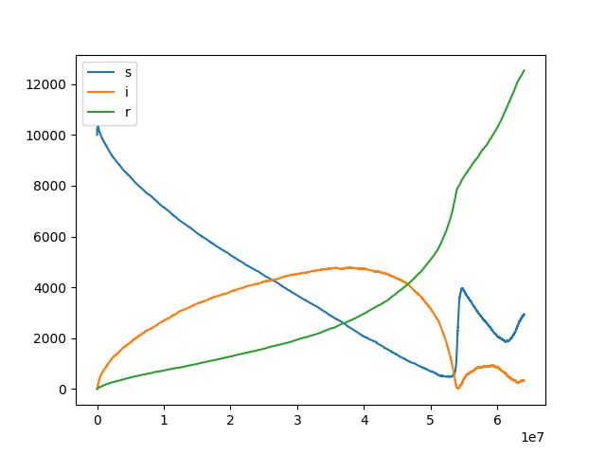

R0=1.5

R0=3.0

1. Scenario where being infected elevates your chance of death from other non-viral factors (x=0.01,y=0.05,z=0.01)

R0=0.8

R0=1.5

R0=3.0